BONCL R-X School District ⯍ 2026-2027 School Supply List
PRE-K & KINDERGARTEN
- Large Glue Sticks (3)
- Crayons – Sm. Box (2 boxes)
- Pencils (1 pkg.)
- Liquid School Glue (1 bottle)
- 1 in. 3-Ring White Binder (1)
*Kindergarten Only - Needs front cover pocket.
- Plastic Folders w/Fasteners
*Pre-K (1 Blue)
*Kindergarten (1- Blue, 1- Green, 1- Red)
- Wet Wipes (2 pkgs.)
- Plastic Nap Mat (1)
- Kleenexes (2 box)
- Disinfecting Wipes
(2 containers)
- Backpack
- Blue Paper Folder w/ Fasteners (1)
1ST & 2ND GRADES
- Scissors
- Dry Erase Markers (1 pkg.)
- Folders (2)
- Wide-Ruled Spiral Notebooks (1)
- Crayons (2 pkgs. 24 count)
- #2 Pencils (2 pkgs. of 12)
- Large Pink Erasers (1)
- Glue Sticks (8)
- Colored Pencils (1 pkg.)
- Markers (2 pkgs.)
- 1 in. 3-Ring White Binder (1)
Needs front cover pocket.
- Kleenexes (2 box)
- Wet Wipes (1 pkg.)
- Disinfecting Wipes
(2 containers)
☐ Index Cards 1 pkg.
- Backpack
- Pencil Pouch
- Art Box

* First Day of School: Tuesday, August 25, 2026*
*

_3RD & 4TH GRADES
- Colored Pencils (1 pkg.)
- Crayons (1 pkg.)
- #2 Pencils (2 pkgs.)
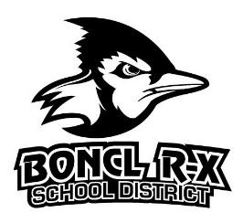
- Dry Erase Markers
(1 pkg.)
- Eraser (1)
- Glue Sticks (2)
- Ruler (12 in.)
- Scissors
- Spiral Notebooks (5)
- Composition Notebook (1)
- 1 in. 3-Ring White Binder (2)
*Needs front cover pocket.
- Highlighters
- Loose Leaf Notebook Paper
(2 pkgs.)
- Folders (5)
- Kleenexes (1 box)
- Disinfecting Wipes
(1-2 containers)
- Art Box
- Backpack
- Washable Markers

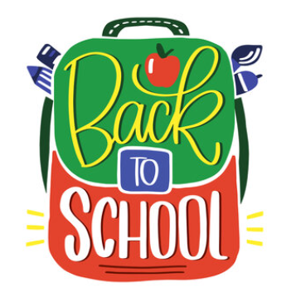

5TH-8TH GRADES
- Colored Pencils or Crayons (1 pkg.)
- Washable Markers (1 pkg.)
- #2 Pencils (2 pkgs.)
- Dry Erase Markers
(1 pkg.)
- Eraser (1)
- Spiral Notebooks (1 Subject – Blue & Green, 3-Subject Yellow)
- Scientific Calculator
- 1 in. 3-Ring White Binder (2)
*Needs front cover pocket.
- Highlighters (2)
- Loose Leaf Notebook Paper
(1 pkg)
- 2 Pocket Hole Punched Folders (1 in each color: red, purple, green, blue and yellow)
- Kleenexes (2 box)
- Disinfecting Wipes
(2 containers)
- Art Box
- 3 Ring Pencil Pouch
- Zipper Binder

